# Lab 02 - Verifying deployed on-prem environment and Landing zone

## Objective

In this Lab we would verify the deployed on-premises environment by first checking the Public IP of the **SmartHotelHost** VM in any browser to launch the **Smart Hotel Application**, if the on-premises has been deployed successfully we should see the Smart Hotel application page showing **Check in** and **Checked Out** guest count.

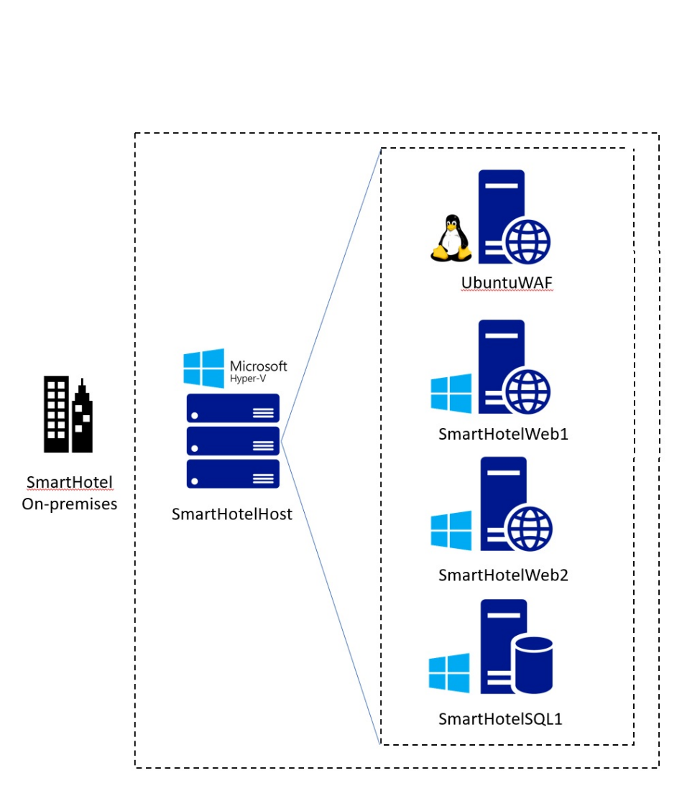

The landing zone that is created on Azure can be verified by checking the **SmartHotelRG** resource group and checking that the required **Network resources** are deployed.

### Task 1: Verify the on-premises environment

1. On your Lab VM open a browser and navigate to +++https://portal.azure.com+++ login using the **Office 365 Tenant Credential** from the **Home/Resources tab** of the Lab interface.
2. Select **Resource group** on home page.

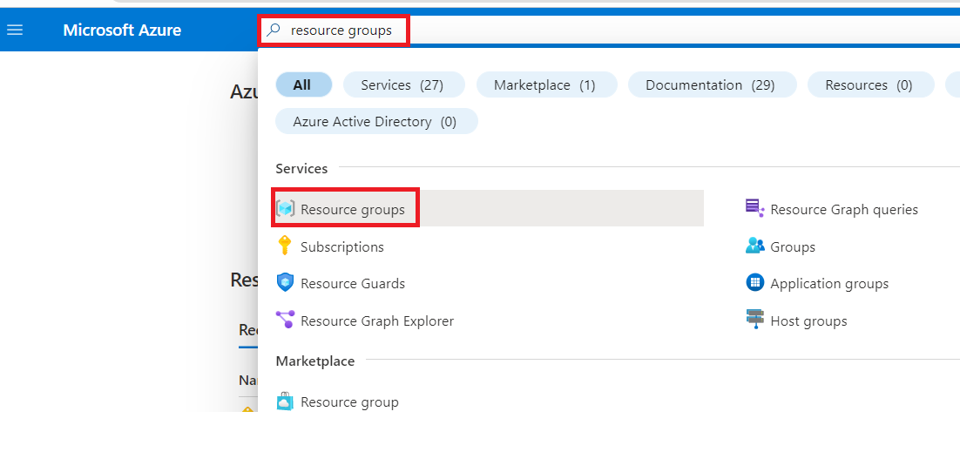

1. Select **SmartHotelHostRG**.

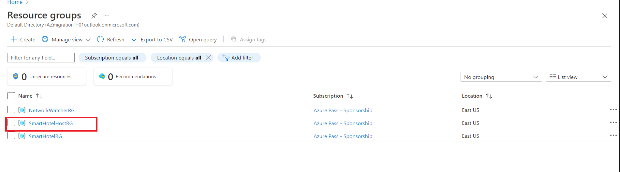

1. Select **SmartHotelHost** VM that was deployed by the template in the previous module.

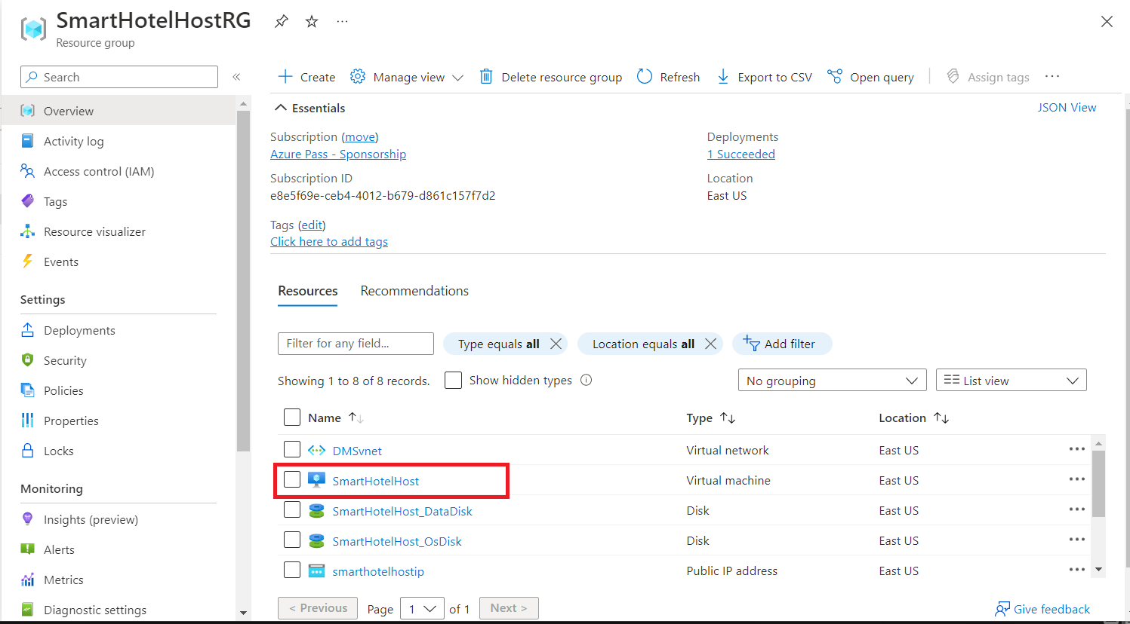

1. Make a note of the **public IP address**.

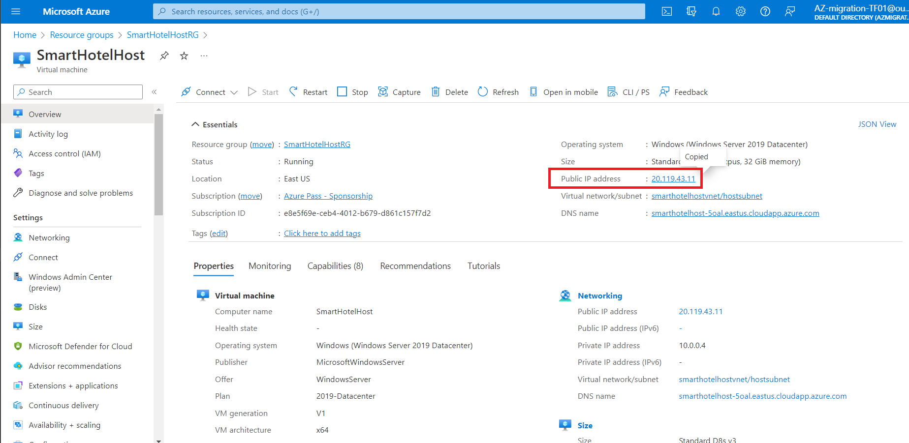

1. Open a browser tab and navigate to **Public IP of the SmartHotelHostVM** (noted in the previous step ). You should see the **SmartHotel** application, which is running on nested VMs within Hyper-V on the SmartHotelHost. (The application doesn't do much: you can refresh the page to see the list of guests or select **'CheckIn'** or **'CheckOut'** to toggle their status.)

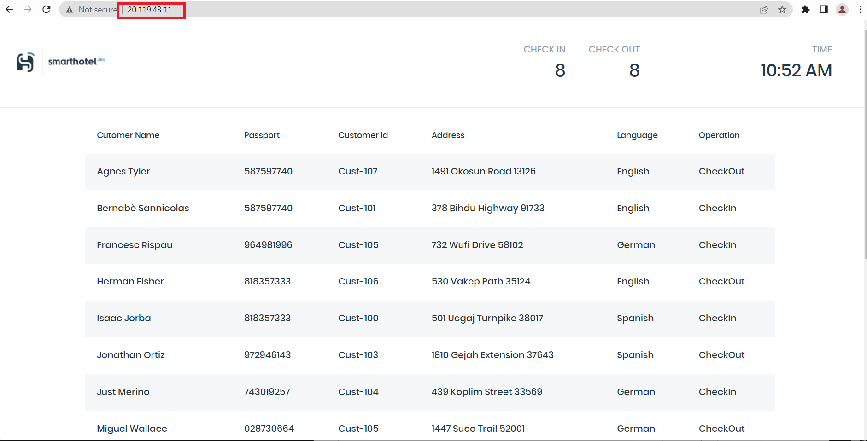

**Note:** If the **SmartHotel application** is **not** shown, wait 10 minutes and try again. It takes **at least 1 hour** from the start of template deployment. You can also check the CPU, network and disk activity levels for the **SmartHotelHost** VM in the Azure portal, to see if the provisioning is still active.

You have completed this task. Do not close this tab to proceed ahead with the next task.

### Task 2: Verify the landing zone environment

1. Switch back to **SmartHotelHost** VM tab and select **Home**.

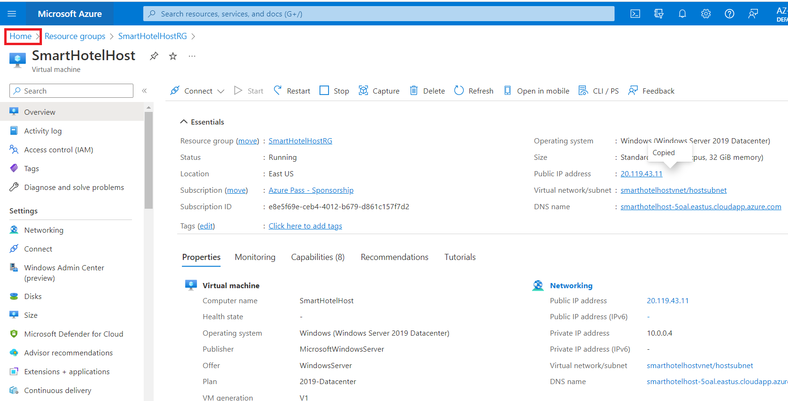

1. Select **Resource Groups** service.

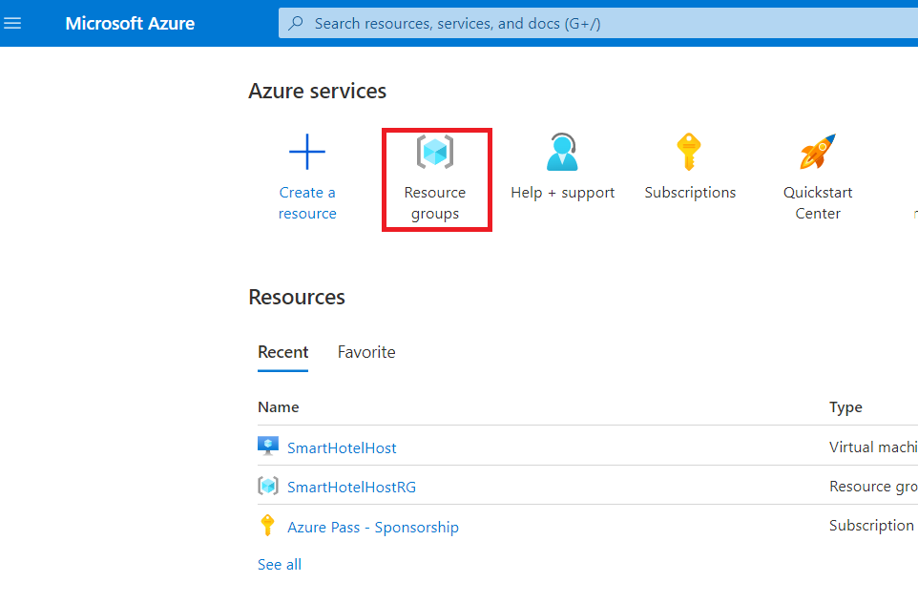

1. Select **SmartHotelRG** resource group.

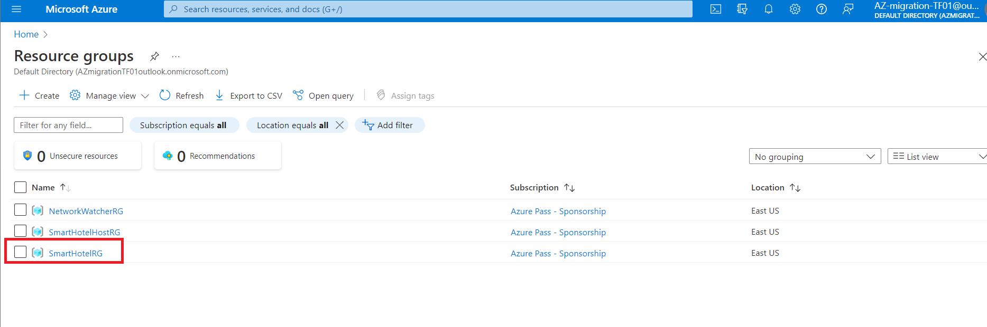

1. Note that the **Virtual Network**, **Bastion resource**, **Application Gateway**, **SQL Server** and, **Database** are available.

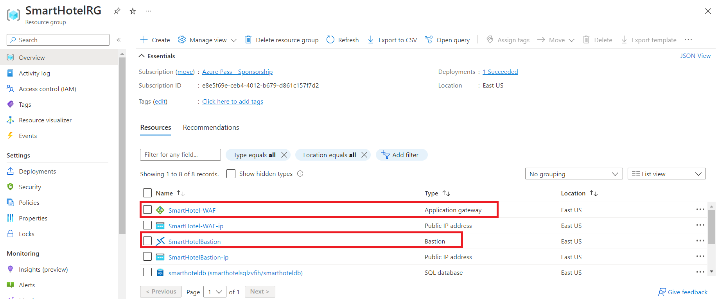

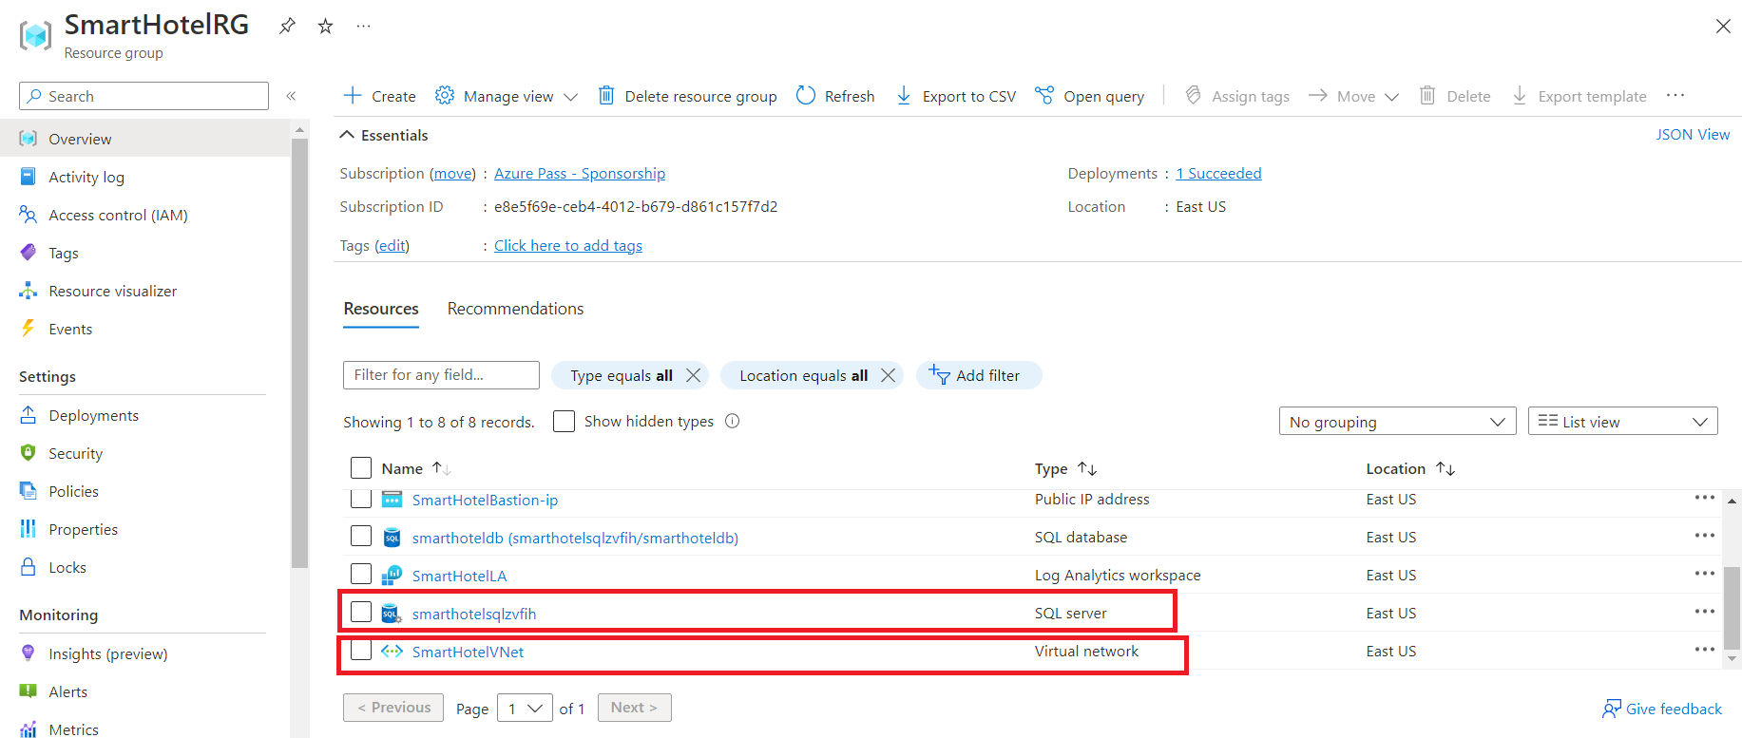

### Summary

At the end of the Lab, we should have successfully verified the On-premises **Smart Hotel Application** which should be up and running. The **Azure Landing zone resource** should be deployed which comprises of Virtual Network, Azure Bastion, Application Gateway, and an Azure SQL Server with an Azure SQL Database.

**Smart Hotel Application**

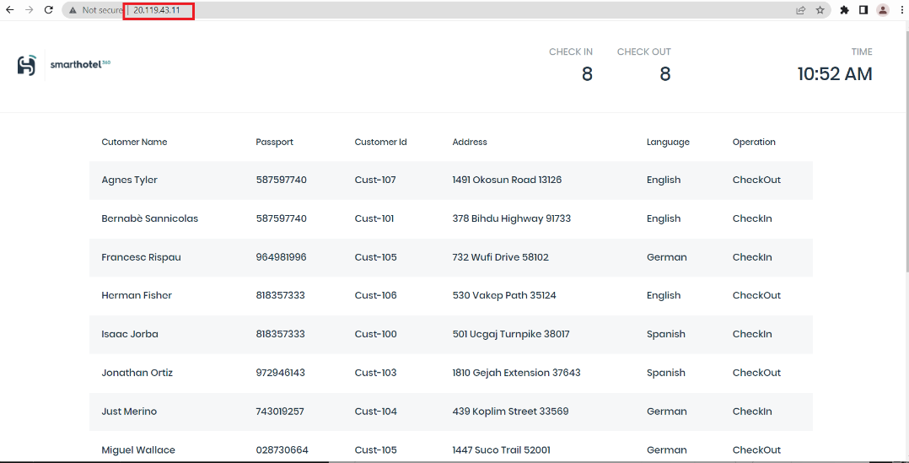

**Azure Landing zone** resource in the **SmartHotelRG**



